**Communicated To: International Journal of computer and information Technology (www.ijcit.com)**

Enhanced Technique To Assist Visually Impaired And Blind People

|  |  |
| --- | --- |
| B V Disha  Govt Engineering College, K R Pet, India  Department of Computer Science and Engineering  Thippegowda B M  Govt Engineering College, K R Pet, India  Department of Computer Science and Engineering | Sowmya B  Govt Engineering College, K R Pet, India  Department of Computer Science and Engineering  Kavana S P  Govt Engineering College, K R Pet, India  Department of Computer Science and Engineering |

***Abstract****—* The issues that millions of people deal with include blindness and vision impairment*.*. They struggle mightily just to finish the most basic of tasks. the endeavor to move independently, even within their own home or place of employment. According to data from the World Health Organization, there are around 250 million individuals worldwide who suffer from visual impairments, of which approximately 35 million are completely blind, making up a significant portion of the population. A state-of-the-art technology solution called the "Blind Assist System Using ML and Image Processing" aims to give visually impaired people more autonomy and safety when navigating their environment. This innovative method blends Image Processing and Machine Learning (ML) to enhance the sensory abilities of the blind or visually impaired.The system utilizes machine learning (ML) techniques to classify and detect items and impediments in the user's path by obtaining and evaluating real-time visual input from the surroundings. It then converts this data into useful advice, giving the user physical or audio input via wearable technology like smart glasses. By abstracting the visible world into understandable facts, this helps people with visual impairments make decisions and move around with confidence while avoiding potential dangers. This innovative system relies on the integration of Machine Learning (ML) and Image Processing techniques to enhance the sensory capabilities of individuals who are blind or visually impaired. By capturing and analyzing real-time visual data from the environment, the system employs ML algorithms to identify and categorize objects and obstacles in the user's path. It then translates this information into actionable guidance, providing auditory or tactile feedback to the user through wearable devices like smart glasses. This comprehends the visual world through abstraction. A notable development in assistive technology, the "Blind Assist System Using ML and Image Processing" holds the potential to improve safety and independence for those with visual impairments.

1. INTRODUCTION

Even simple daily tasks are extremely difficult for able-bodied individuals with visual impairments to accomplish. Most of them are compelled, against their will, to depend on others for help.. For the benefit of these people, thousands of technologies are being created or have already been produced. Among these technologies, computer vision is one that offers the most promise. It is difficult for blind persons to navigate the roadway. They are frequently at danger of being struck by obstacles and vehicles since they are blind. One of the most important senses for humans is sight, which is crucial to how we perceive our surroundings. Mobility is essential for people with visual impairments to be able to provide, experience, and imagine their vision. Two categories of vision impairment—distance and near presenting visual impairment—are recognized by the International Classification of Diseases 11 (2018).[6] Uncorrected refractive errors, cataracts, age-related macular degeneration, glaucoma, diabetic retinopathy, corneal opacity, trachoma, and eye traumas are the main causes of vision impairment in the world.

It affects the quality of life and independence of visually impaired people by restricting their capacity to travel and carry out daily duties as well as their ability to engage with the outside world. Numerous alternatives, like the Eye-ring project, text recognition system, hand gesture, and facial recognition system, have been launched as a result of technological advancements. These solutions do, however, have many drawbacks, such being costly, bulky, fragile, and not widely accepted. Therefore, sophisticated methods must develop to assist them. Thus, we suggest a system based on the latest developments in machine learning and image processing.

The suggested system takes pictures in real time, preprocesses them by separating the foreground and background, and then

applies a DNN module with a trained YOLO model to extract features. To identify the objects, the retrieved features are compared to features of known objects. Using text-to-speech conversion, the object name is voice output after it has been successfully recognized.

The paper's main contributions are as follows:

● Accurate and reliable item identification and detection to enable blind and visually impaired individuals to freely navigate both familiar and unfamiliar areas and stay safe.

● Speech output and text-to-speech conversion offline.

1. MOTIVATION

1. **Need for Independence**: People with visual impairments frequently find it difficult to get around on their own. By offering a technology solution that increases their autonomy and lessens their dependency on outside help, the project seeks to empower them.

2. **Safety Concerns**: Since visually impaired people are more likely to come across hazards and barriers in their surroundings, safety is a top priority for them. The initiative aims to increase safety by helping users recognize and avoid barriers more skillfully by utilizing machine learning and image processing capabilities.

3. **Accessibility to Information**: People with visual impairments may find it difficult to interact with written materials because they are unable to access printed information. In order to solve this problem, the project incorporates text recognition capabilities that enable users to utilize audible feedback to access a variety of printed materials.

4. **Technological breakthroughs**: As a result of technological breakthroughs, there is an increasing chance to create creative ways to help those who are blind or visually impaired. The initiative seeks to utilize the advances in machine learning and image processing to make the world more accessible and inclusive.

5. **Impact on Quality of Life**: The project's main motivation is to raise the standard of living for people who are blind or visually impaired. The goal of the initiative is to improve their general well-being and encourage more independence and confidence by giving them the tools and resources they need to navigate their environment more skillfully.

6. **societal Responsibility**: It is a societal responsibility to attend to the needs of marginalized groups, including blind people. With the goal of establishing a more equitable society where everyone has equal access to opportunities and resources, the project is in line with the values of inclusion and equity.

7. **Potential for Innovation**: The project offers a chance for technological innovation and advancement in the assistive technology space. The project intends to expand the possibilities for helping visually impaired people by creating innovative solutions that combine machine learning and image processing.

The "Blind Assist System Using ML and Image Processing" project is driven by the goal of significantly improving the lives of visually impaired people by arming them with the means to better navigate their environment, increase their safety, and improve their general quality of life.

1. LITERATURE SURVEY

Helping the Blind with Vocal Feedback and Object Detection[1] The suggested method proposes to identify items in real-time video by utilizing a web camera for object detection. The CNN-based You Look Only Once (YOLO) model is used as a real-time object detection method. Furthermore, the software program is implemented using the Python OpenCV libraries, and the deep learning procedure is carried out..Using the Google text-to-speech library, image recognition results are spoken aloud to visually challenged users, allowing them to locate objects based on their screen positions. The mean Average Precision (mAP) was utilized to assess the obtained result, and it was discovered that the suggested method outperforms earlier approaches in terms of results

Reader and Blind Object Detector [2] The purpose of this effort is to help visually impaired individuals read text and identify items in their environment. An image obtained from the web camera is used as the input. After then, depending on the user's preference, this image is either processed for text reading or object detection. The entire procedure is processed by the Raspberry Pi, which serves as the microcontroller. OCR software is used to support text reading. The TTS Synthesis converts the read text into an auditory output. The Tesseract Library is one of the other dependencies needed for the procedure. Another project component that uses a TensorFlow Object Detection API to be built is Object Detection.

It can recognize a variety of objects in its environment and generate an aural response. The dataset is scalable because it may be trained on a range of scenarios according on the needs of the user.

Robot Eye: Using Deep Attention Network for Automatic Object Detection and Recognition to Help the Blind[3] In computer vision, detection and recognition is a well-known field with many unanswered questions. The ability to use a ZED stereo camera—a camera that can compute depth information—to guide blind persons through an outside setting is one of the research's primary accomplishments. In this paper, we propose an autonomous object detection and recognition system using a deep attention network. In order to assist blind individuals in crossing roads and making purchases in businesses, the objects are not limited to just regular people or cars. They also feature convenience stores and traffic signals. Due to the limited availability of public datasets, we additionally generate a new dataset using pictures from Google Street View that were taken with the ZED stereo camera. Our approach outperforms naive YOLO v3 with an accuracy rate of roughly 81% when testing with images of varying resolutions.

Image Processing for Blind Persons' Visual Assistance[4]

People who are visually impaired deal with several challenges in their daily lives. They frequently rely on assistance from others. Numerous technologies have been created to aid individuals who are visually impaired. Due to their accessibility and cost, computer vision-based solutions are starting to stand out among the many technologies being used to help the blind.

This research suggests a system for individuals with vision impairments. The goal of the proposed system is to provide visually impaired individuals with a wearable visual assistance that can recognize verbal commands from the user. Its functions include item and sign board identification. This will make it easier for the blind individual to go about their daily lives and navigate their environment.

1. PROPOSED SYSTEM

When it comes to situations like crossing traffic lights, the current systems, such as blind sticks, are ineffective since the sticks cannot tell if the light is green or red. Furthermore, a stick cannot detect obstacles until it makes touch with an object; a blind stick cannot discriminate between different kinds of barriers.

Our approach to solving the issue is to develop a gadget that can use a camera to identify obstacles and a voice output of obstacles. The system runs on laptop using web camera and laptop speaker.

This device will capture video of its surroundings continually and turn it into frames. Following an analysis of these frames, the system will notify the user of any surrounding obstacles. The system's mobility, affordability, and accessibility are its main advantages; image processing technology allows it to help people with vision impairments.

With the use of this device, visually challenged individuals will be able to see their surroundings and overcome any obstacles in their path.guaranteeing thorough coverage in detecting content manipulation.

The project has two functionalities:

1. Object detection and audio output: To detect an object, a camera is attached, and live video is acquired. The video is then converted into image frames, which are used to identify the object. To do this, we have a pre-trained dataset called COCO dataset, which contains 91 objects that have been trained. We compare the objects from the dataset to identify the object, obtain the object's label, and then use the ESPEAK library to convert the labeled object's audio.

2. Text recognition and audio conversion: The first stage is to use a camera to capture live footage. The process of converting video into picture frames will be utilized to identify text inside the image. The image is then preprocessed using the open cv package to obtain the necessary resolution. Before the preprocessed image is transferred to the Tesseract library, which uses a convolution neural network to recognize text, it is first passed to the ESPEAK library, which converts the image to audio and uses a speaker to announce.

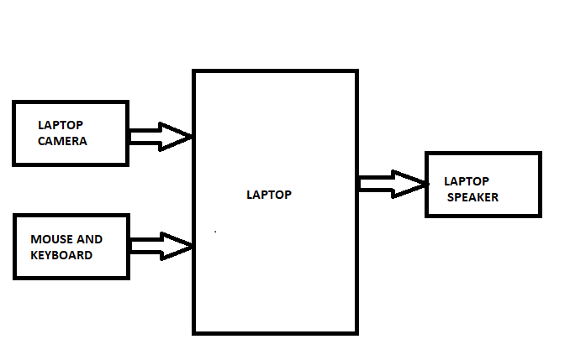 Fig.1 System Architecture

*1. Interface for Users (UI):*

●Input Interface: Camera input for object identification and book reading; user controls to start/stop different capabilities.

The output interface uses text-to-speech (TTS) to give the user information.

●Read text and hear audio feedback for objects recognized.

*2.Object Detection Module*:

●Pre-trained Model: YOLO, SSD, or Faster R-CNN, trained on COCO dataset.Tailored instruction for particular object classes (books, for example).

●Intelligent Object Identification: Combining camera data with the system.Recognize and categorize items in the user's surroundings.

*3.Book Reading Module:*

●Text Extraction: Text can be extracted from photos using an OCR module (such as Tesseract).Preprocessing images to improve text recognition.

● Text-to-Speech (TTS): Use a TTS engine to turn extracted text into speech, such as Google Text-to-Speech.To improve user experience, change the pitch and pace of your speech.

*4.Image Processing Module:*

Improve image quality using techniques including contrast modification, noise reduction, and sharpening for improved object detection and text extraction*.*

*5.Book Detection Module:*

● Makes use of the object detection module to distinguish books in particular.

● Triggered when the user desires to start the feature for reading books.

*6.Control and Integration Layer:*

● Coordinates communication among various modules.

● determines when to activate object detection or book reading based on input from the user..

*7.Feedback and Notification:*

● Coordinates communication among various modules.

● Determines when to activate object detection or book reading based on input from the user.

*8.Accessibility Features:*

● Voice instructions for control without using hands.

● Taking into account different input techniques (such as buttons and gestures).

*9.Security and Privacy:*

Ensure that user data is handled securely. Put in place safeguards to preserve user privacy when capturing and processing images.

*10.Testing and Debugging Tools:*

● Tools to verify the system's correctness, performance, and functionality.

● Debugging tools to identify problems instantly.

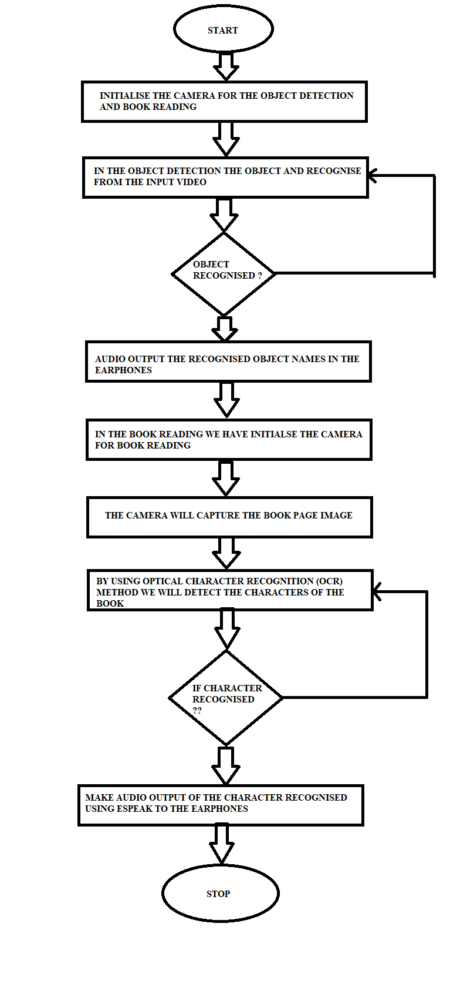

Fig2. Workflow

User Initiates Object Detection:

●Activated through the UI.

Object Detection Module:

●Identifies and classifies objects in real-time.

Book Detection:

●If the user requests book reading, the system focuses on detecting books.

Text Extraction and Reading:

●OCR extracts text from the book.

●The TTS module converts the extracted text into speech.

Audio Feedback:

●The system provides audio feedback to the user about detected objects or read text.

1. RESULT

The proposed system is useful for blind and visually impaired people. It not only helps them avoid any obstacle but also helps them knowing the distance of object from the user with regular audio alert about the proximity range. So, the proposed system focuses on the identification of the objects. The text reading functionality takes approximates 1 second to recognize a sheet of paper and audio will be generated and will be played through earphone. We have addressed the problems of making a portable, affordable, accessible system for the use of blind people with the use of laptop.

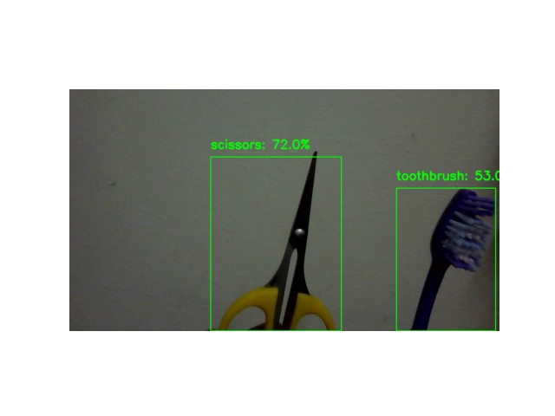

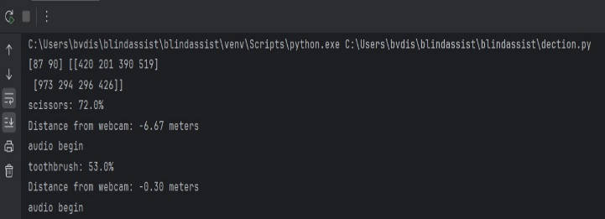

The above figures show the output for sissors and toothbrush.

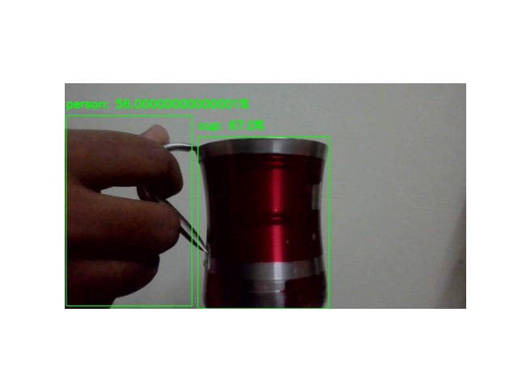

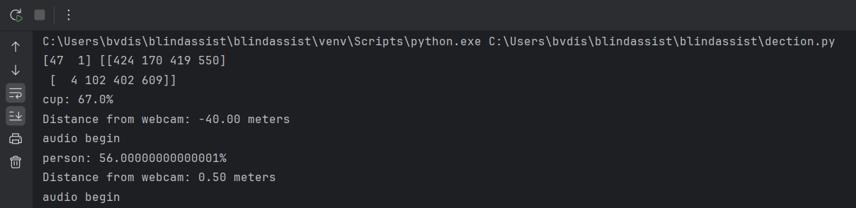

The above figures show the output for cup and person.

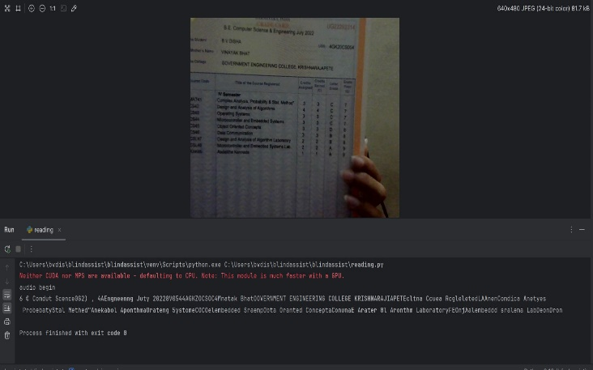

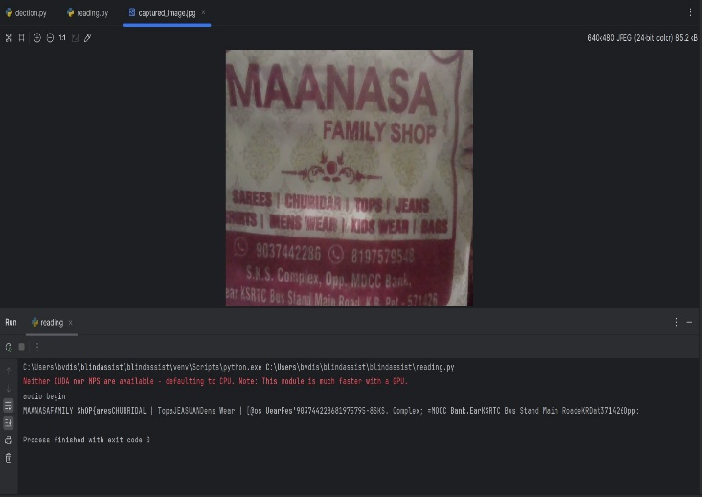

The above figures show the output for reeding module.

1. References

[1] Rajani Suryakant Kolhe, Kajal Gajanan Dhole, Pratibha Sampat Thakre, Priyanka Sohan Prasad,” Smart Stick for The Blind and Visually Impaired People”, International Journal of Scientific Research in Science, Engineering and Technology, pp.207-210,2021.

[2] Yeong-Hwa Chang, Nilima Sahoo and Hung-Wei Lin,” An Intelligent Walking Stick for the Visually Challenged People”, Proceedings of IEEE International Conference on Applied System Innovation 2018, IEEE ICASI 2018- Meen, Prior & Lam (Eds).

[3] K. B. Swain, R. K. Patnaik, S. Pal, R. Rajeswari, A. Mishra and C. Dash, "Arduino based automated STICK GUIDE for a visually impaired person", IEEE International Conference on Smart Technologies and Management for Computing, Communication, Controls, Energy and Materials (ICSTM), pp. 407- 410, 2017.

[4] Nadia Nowshin, Sakib Shadman, Saha Joy, Sarker Aninda, Islam Md Minhajul, “An Intelligent Walking Stick for the Visually Impaired People", International Journal of Online and Biomedical Engineering (iJOE), vol. 13, No. 11, 2017.

[5] The publication "Implementation of Smart Stick for Obstacle Detection and Navigation" was published in the International Journal of Latest Research in Engineering and Technology (IJLRET) in 2016. Radhika R, Payal G Pai, Rakshitha S, and Rampur Srinath.T. Siva Sankara Phani, A. Pravin, and Manikanta K. (2018) "Implementation and Design of Smart Blind Stick for Obstacle Detection and Navigation System.